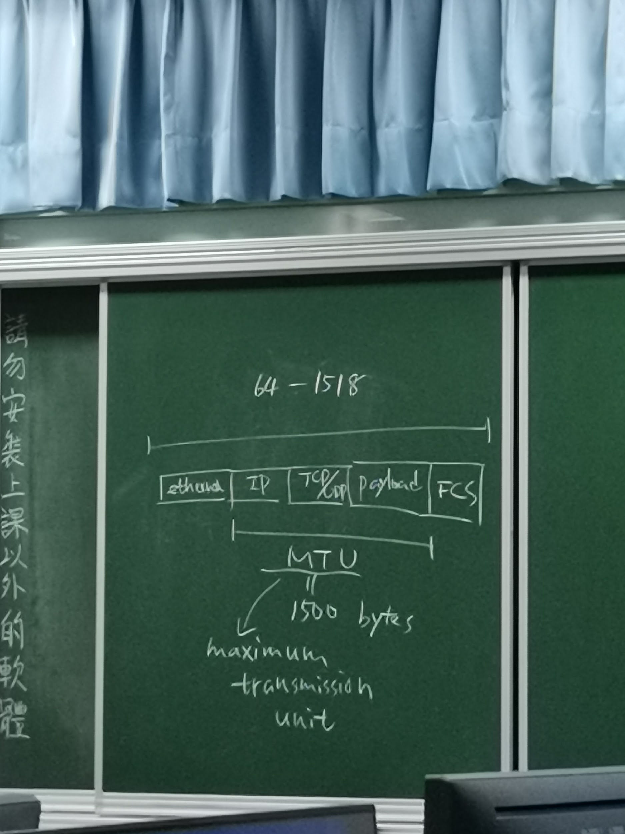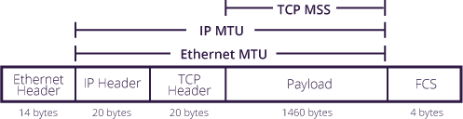

Ifconfig enp0s3

Ifconfig enp0s3 | grep broadcast

Ifconfig enp0s3 | grep netmask

Ifconfig enp0s3 | grep broadcast | awk ‘{print $2}’

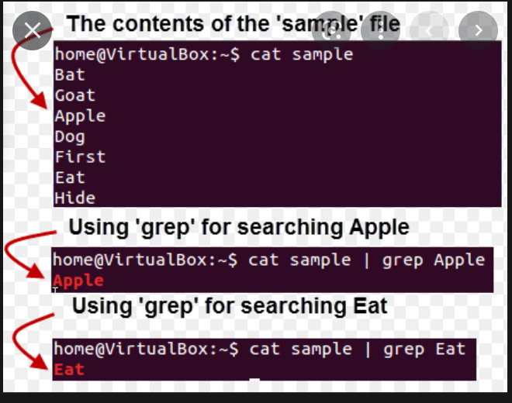

In linux use,

Route -n

In windows cmd,

Route print

Ping -c 1 8.8.8.8

//uses to ping endlessly to 8.8.8.8, and also print out the buffer size

Ifconfig enp0s3 hw ether 00:00:00:00:00:01

//to change the ethernet ip address

Ifconfig | grep inet | grep -v inet6 | awk ‘{print $2}’

if config | grep inet

//to print all the ip address available in the computer

To shutdown computer:

Poweroff

Shutdown

-h now

Halt -p

To reboot the computer:

Reboot

Shutdown

-r now

List of storage device names:

Fat32

NTFS

efat

Code use to check:

Ext 2

Ext 3

Ext 4

Xfs

History

//to see all the command entered from this session



Df -h

//(short for disk free), is used to display information related to file systems about total space and available space.

Cd /

Ls

Mount -a

//use to mount the disk -a

